Mission 1 Assignment Log | Name:
Pre-Mission Preparation
All electronic devices have circuit boards inside, and a way to get input and give output. List several devices you use or see everyday and how their input/output devices.
Technology is used in medicine, education, industry, fast food restaurants, entertainment, and much more. How is your life impacted by technology?
Mission 1 Checks
Objective #1
Click on the “Hints” and review the Python knowledge base. Which skills are you comfortable with?
Objective #3  Label the connection ports (PORT #) and expansion ports on the CodeX. | 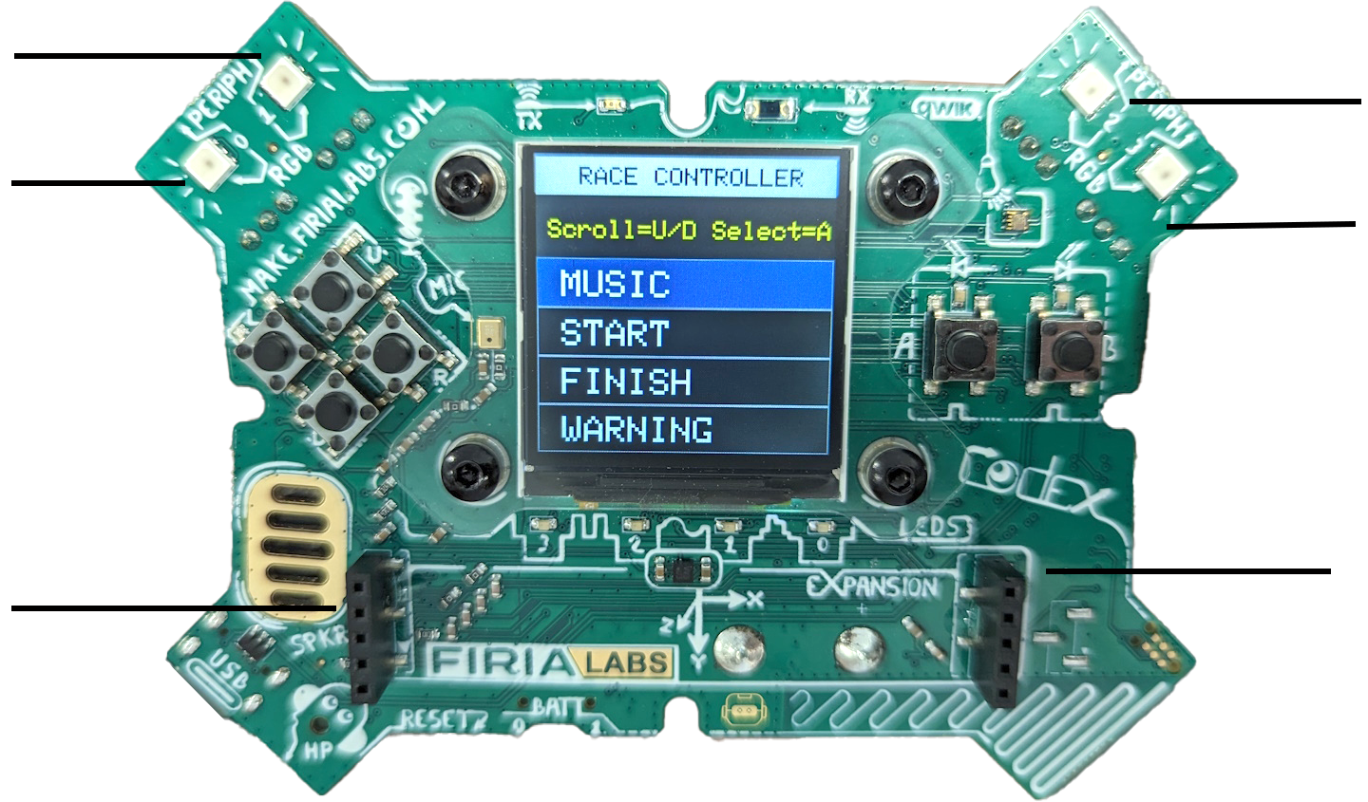
Objective #4  Fill in the information about the connecting cables. | Wire color Purpose Connects to  Yellow  Red  Black
Objective #5
What library is used to set up peripherals and give them power?

What information needs to be included to set up a peripheral?
Objective #6
What are two things you can do to make your code more readable and meaningful?
Post-Mission Reflection
What is something you learned about peripherals from this mission?
What is something you looked forward to doing in future missions?

